SRS – Committee Member User Stories
Apartment Building Management System

Proposal: Committee Member Part
Project: Apartment Building Management System
My part: Committee Member user class
The problem. Residents see the accounts once a year, if that (SRS 1.4). Rates agreed at meetings are written on paper, so there are disputes about what was agreed and no record of changes. Spending is approved informally, in person or in a group chat. Complaints go through personal conversations, and residents fear being named.
What I propose. I will write the Committee Member part of the SRS. It describes one system where the committee sets the charge rates after each meeting, approves or rejects every expense before it counts, reads the monthly fund summary and the late-ticket count before a meeting, and reads anonymous feedback by service. The committee is linked to the other users. The manager makes the bills from its rates, records the expenses it decides on and publishes the fund summary. Residents pay at its rates, see the same totals and send the feedback it reads.

Goals for the committee member
Every charge rate is saved with the meeting that agreed it, and bills already made keep their old rates.
Every expense is approved or rejected, and only approved expenses count in the fund.
The committee sees the fund totals each month, never which flat owes what.
Residents' feedback reaches the committee without showing which flat or account sent it.

What is in this part
Area | What the committee member does | Stories
Log in | Logs in to the committee screens | CM-05
Charge rates | Sets the service, generator and water rates after a meeting, and reads the rate history | CM-01
Expenses | Approves or rejects each expense the manager records, and the opening balance | CM-02
Fund and building health | Reads the monthly fund summary and the count of late tickets | CM-04
Feedback | Reads residents' anonymous ratings and comments by service | CM-03

1.5 Risk Definitions (Committee Member)
Risk | What could go wrong | Likely / impact | How we handle it
R-06  Private data leaks | Private data leaks: phone numbers to staff, one flat's bills to another, or a previous tenant's history to the new one. | M / H | Role and flat-level access checks, occupancy periods, totals-only fund view (NFR-06, NFR10, NFR-12, NFR-13, BM-02).
R-09  Account takeover or lock-out | An account is taken over, or someone keeps a flat locked out by entering wrong passwords. | M / M | Hashed passwords, non-guessable usernames, and wrong-password delays per device instead of per account (NFR-04, NFR05).
R-12  Spending counted before approval | Spending is counted before the committee approves it, or rates change without a record. | L / H | Only Approved expenses count; every rate change stores who, when, old and new value and the meeting date (CM-01, CM-02, NFR27).
R-13  Fault ticket with nobody assigned | A fault ticket sits with nobody assigned. | M / M | Late tickets highlighted for the manager and counted on the committee dashboard (BM06, CM-04).
R-17 (proposed) Incomplete fund picture | Expenses wait so long for a decision that residents see an incomplete fund picture for the month. | M / M | The summary leaves out waiting expenses and says how many are waiting (BM-12). The committee sees the same count (CM-04).
R-18 (proposed)  Receipt not read | A member approves an expense without reading its receipt. | M / M | The receipt and description are shown before the buttons (CM-02). Software cannot prove the receipt was read, so this risk is accepted.
R-19 (proposed)  Wrong meeting date | A rate is entered with the wrong meeting date, so a later dispute cannot be settled from the record. | L / M | The meeting date is required and blank dates are refused (CM-01); the history keeps every value (NFR-27).
R-20 (proposed) Former member still approves | A former committee member keeps approving after leaving the committee. | M / M | The manager deactivates the account (BM02); a deactivated account is refused at log-in (CM-05).

2.1 User Class: Committee Member
A committee member is an elected flat owner who oversees the building fund. Members are unpaid and use the app about once a month, around the committee meeting. Decisions are made at the meeting, and at least one member enters them in the app, so members who never log in still take part. The secretary and treasurer have the same permissions as other members in Release 1. Members use their own phone (most) or a laptop, prefer Bangla or English, and their technical skill varies widely.
The committee is the link between the building manager and the residents. It sets the charge rates the manager uses to make bills, and it approves or rejects the expenses the manager records. It reads the fund summary the manager publishes and the feedback residents give. It does not make bills, record payments or assign tickets.
Action | Committee member
Set charge rates | Yes
Approve or reject expenses and the opening balance | Yes
See the fund summary (totals only, never which flats owe) | Yes
Read resident feedback (anonymous entries show no flat) | Yes
Read announcements (announcements to all residents also reach committee members, BM-11) | Yes
See emergency numbers (999 always first) | Yes
Record expenses; publish the monthly fund summary | No (manager)
Make and correct bills; accept or reject a payment claim | No (manager)
Create and deactivate flat, guard, maintenance and committee accounts | No (manager)
See a resident's phone number | No
Operating environment (SRS 2.3): members use their own phones (mostly Android, Chrome browser) and some use a laptop browser. They connect over mobile data or home Wi-Fi, and load-shedding often takes Wi-Fi down, so the screens must work on slow mobile data.

2.2 User Needs
Class | How it works today | Problem | What they need | Stories
Committee | Rates agreed at meetings, written on paper | Disputes about what was agreed; no record of changes | Set rates in the app with a full history | CM-01
Committee | Receipts shown in person or in a group chat | Spending approved informally | Approve or reject each expense with its receipt | CM-02
Committee | Complaints through personal conversations | No overview; residents fear being named | Anonymous ratings and comments per service | CM-03
Committee  (proposed) | Residents see the accounts once a year, if that (SRS 1.4) | Shortages found late; no monthly view of the fund or of open problems | See each month's fund and the building's open problems before the meeting | CM-04
Rows 1 to 3 are SRS 2.2 wording. Row 4 is proposed: SRS 2.2 has no committee row for the fund.
3.1 Functional Requirements: User Stories and

Confirmation
Each story has its confirmation written as Given / When / Then. Priority is Must, Should or Could. "Touches" shows which other user's story it depends on.

CM-01 · Set charge rates · Must
As a committee member, I want to enter the charge rates agreed at the meeting, so that the bills the manager makes use the committee's rates.
Given I enter a new rate for service, generator or water and the date of the meeting that agreed it, when I save, then it is used for bills made after the save.
Given bills for a month already exist, when I change a rate, then those bills keep their old rates.
Given a bill run is in progress, when I save a new rate, then the run finishes with its starting rates and the new rate applies from the next run.
Given I enter a blank or negative rate, or leave out the meeting date, when I save, then I see "Enter a valid rate and meeting date" and nothing changes.
Given a rate has changed, when any member opens Rate history, then they see who changed it, when, the meeting date, and the old and new values.
Touches: BM-03, RES-01.

CM-02 · Approve or reject expenses · Must
As a committee member, I want to approve or reject each expense with its receipt, so that only spending the committee agreed is counted in the fund.
Given an expense is Waiting for approval, when I approve it, then it becomes Approved and is counted in the fund summary.
Given an expense is Waiting for approval, when I reject it with a reason, then it becomes Rejected, isn't counted, and the manager sees the reason. Without a reason I see "Write a reason" and nothing changes.
Given an expense is already Approved or Rejected, when I try to decide it again, then I see its current status and nothing changes.
Given the manager has entered the first month's opening balance, when I approve it, then the first summary can be published to residents.
Touches: BM-08, BM-12, RES-05.

CM-03 · Read resident feedback · Could
As a committee member, I want to read residents' ratings and comments, so that I know which services are working.
Given residents have sent feedback, when I open Feedback for a month, then I see each service's average rating, the number of ratings and the comments.
Given feedback was sent anonymously, when I view it, then no flat number or account name is shown, on screen or in exports.
Given no feedback exists for the month, when I open it, then I see "No feedback for this month".
Touches: RES-07.

CM-04 · Check the fund and building health · Should
As a committee member, I want to see each month's money and the building's open problems, so that I can check the accounts and the manager's work before the meeting.
Given a summary is published, when I open Fund summary, then I see the same figures as residents plus how many expenses are waiting for approval.
Given some flats are unpaid, when I view the summary, then I see only the total outstanding, not which flats owe it.
Given the month isn't published yet, when I open it, then I see "Not published yet" and the last published month.
Given tickets have waited past the late limit with nobody assigned (BM-06), when I open the dashboard, then I see how many there are.
Touches: BM-12, BM-06, RES-05.

CM-05 · Log in to the committee screens · Must
As a committee member, I want to log in with my own committee account, so that only committee members can change rates and approve spending.
Given I enter the right username and password, when I log in, then I see the committee dashboard.
Given 5 wrong passwords in a row from one device, when I try again, then that device must wait 15 minutes (BR-14).
Given the manager has deactivated my committee account, when I try to log in, then I am refused and my past decisions stay in the record.
Given I am a resident, guard, maintenance or manager user, when I try to open a committee page, then access is refused.
Note: A committee member who also lives in the building uses the household account for their flat and this account for committee work.
Touches: BM-02 (creates committee accounts).

3.2 Non-Functional Requirements
The requirement text and the Stories column are copied from SRS 3.2. A row is shown when it applies to a committee story or to All stories. A * marks a row where SRS 3.2 does not list the committee story yet; that is a proposed addition. NFR-16 (emergency screen in at most 2 taps) is meant for every role, but SRS 3.2 lists no committee story for it, so it is not shown.
ID | Category | Requirement | Story
NFR-01 | Performance | The Dues, Tickets, Visitors inside, Defaulters, Fund summary and dashboard pages shall load within 3 s for 95% of requests, measured on a throttled "Fast 3G" connection (about 1.6 Mbps) with data for 200 flats. | CM-04
NFR-03 | Security | All traffic shall use HTTPS (TLS 1.2 or later). Plain HTTP requests shall be redirected to HTTPS. | All
NFR-04 | Security | Passwords shall be at least 8 characters and stored only as salted hashes (bcrypt or Argon2). Passwords shall never be stored, logged or emailed in plain text. Temporary passwords shall expire after 7 days if unused. | All log-in stories  (CM-05)
NFR-05 | Security | Wrong-password protection shall work per device as set out in BR-14.  Usernames shall be generated and shall not be the flat number. | All log-in stories  (CM-05)
NFR-06 | Security | Every page and API shall check the user's role. A resident shall reach only their own occupancy's data; maintenance staff only their assigned tickets. Automated tests shall cover every page and API for every role. | All
NFR-07 | Security | Sessions on shared or work devices (guard, maintenance) shall end after 15 minutes idle. Resident, manager and committee sessions shall end after 7 days idle. | CM-05 *
NFR-09 | Security | Uploaded photos shall be JPG or PNG of at most 5 MB, compressed on the phone to about 1 MB before upload. Other file types shall be refused. | CM-02 * (receipt photo)
NFR-11 | Privacy | Anonymous feedback shall never show the flat or account to any reader, on screen or in exports. The link to the flat is stored only to replace repeat feedback. | CM-03
NFR-12 | Privacy | Residents and committee members shall see fund figures as totals only, never which flats owe money. | CM-04
NFR-17 | Safety | If a save fails because of a connection or server error, the app shall show an error within 5 s and shall never show the change as saved. | All
NFR-19 | Availability | All other functions shall be available 99% of the time between 06:00 and 24:00, measured monthly. Planned maintenance shall happen between 01:00 and 05:00 with 24 hours' notice by announcement. | All
NFR-22 | Usability | Every screen shall be available in Bangla and English, switchable by the user at any time. Amounts shall show in BDT (৳) and times in Asia/Dhaka (BR-01). | All
ID | Category | Requirement | Story
NFR-23 | Usability | Screens shall work at 360 px width with no sideways scrolling, use touch targets of at least 48 × 48 px, and stay usable with the phone's text size at 150%. | All
NFR-24 | Usability | From the user's home screen: paying the current bill, creating a guest pass, assigning a ticket, accepting a claim and approving an expense shall each take at most 4 taps; checking a pass at most 3 taps plus entering the code; opening an assigned ticket at most 3 taps. | CM-02
NFR-25 | Usability | Every error message shall say what went wrong and what to do next, in the user's chosen language. The messages quoted in 3.1 are the required wording. | All
NFR-26 | Accuracy | Bill totals, balances, the defaulters list and the fund summary shall always equal the sum of the saved records. Each payment, check-in and carried-forward amount shall be counted exactly once. | CM-02 *, CM-04 *
NFR-27 | Auditability | Every change to accounts, occupancies, bills, payments, claims, rates, expenses, tickets, passes and gate records shall be logged with the acting account, date and time, and old and new values. Log entries cannot be edited or deleted and are kept for at least 5 years. | All
NFR-28 | Compatibility | The app shall run in Chrome on Android 8 or later and in current Chrome, Edge and Firefox on desktop, and shall be installable as a progressive web app. | All
NFR-30 | Maintainability | Interface text shall live in language files, not in code. Charge types, fault categories, common-area places and emergency numbers shall be changeable without a code change. | All
NFR-31 | Capacity | One installation shall support a building of up to 200 flats, 1,000 user accounts and 50 people using it at the same time without breaking NFR-01. | All
* SRS 3.2 does not list this committee story for the row yet. Proposed addition, also for the traceability matrix (SRS 3.3).

4. UML Use Case Diagram
The Committee Member is the main actor. The Building Manager and the Resident are the other actors who take part in a use case. Every committee use case except Log in and Set new password includes UC-C01 Log in. Each figure repeats Log in, and the «include» arrows run to it along a bracket. Decide expense is abstract (in italics): Approve expense and Reject expense specialise it, so they inherit its «include». The «extend» from Set new password is a proposal, because SRS Appendix B shows only the Log in precondition. Items marked proposed are not SRS text.
Log in
(
UC
-C01)
Set new password
(
UC-C02, proposed
)
Committee Member
Accounts and Login
«extend»
[
first log-in with a
temporary password]
Figure 4.1: Accounts and Login
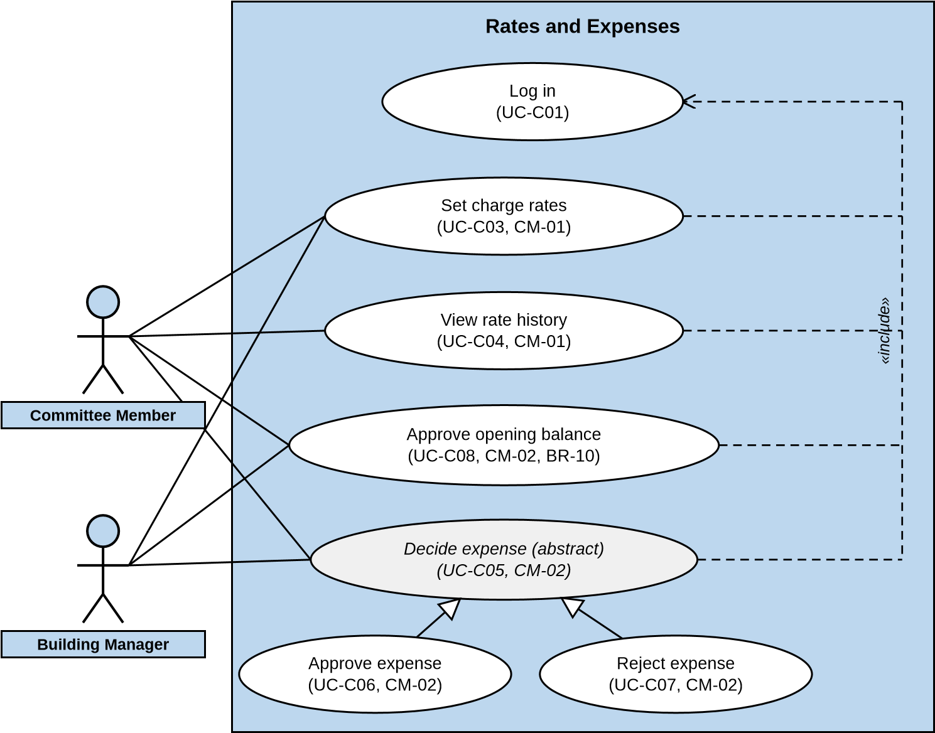
Figure 4.2: Rates and Expenses
Log in
(
-C01)
UC
View fund summary
-04)
UC-C09, CM
(
Read resident feedback
-03)
(
UC-C11, CM
View building health
(
UC-C10, CM
-04)
Committee Member
Resident
Building Manager
Fund, Health and Feedback
«
i
n
c
l
u
d
e
»
Figure 4.3: Fund, Health and Feedback

5. Use Case Narratives
Each narrative lists the actors, the condition before it starts, the main steps, the other paths, the result and the rules it must meet. Other paths are numbered after the step they branch from, so 2a branches from step 2. The committee member is the primary actor in all of them. Business rules (BR), stories and NFRs are cited in brackets.

UC-C01 Log in (CM-05)
Actors: Primary: Committee Member.
Before: The manager has created the committee account (BM-02) and the account is active.
Main steps:
- The committee member opens the app while logged out, and enters the username and password.
- The system checks them and checks that the account is active.
- The system opens the committee dashboard.
Other paths:
2a. First log-in with a temporary password → «extend» Set new password (UC-C02), then step 3.
2b. Wrong username or password → error shown (NFR-25), return to step 1. After 5 wrong passwords in a row from one device, that device must wait 15 minutes (BR-14).
2c. Account deactivated → log-in refused; past decisions stay in the record (CM-05).
2d. Temporary password not used within 7 days → refused; the member asks the manager for a new temporary password (NFR-04, BM-02).
After: The committee member is logged in and sees the committee screens. A member who also lives in the building uses the household account for flat matters (RES-06). It is a separate log-in (note under CM-05).
Rules: HTTPS only (NFR-03). Passwords stored only as salted hashes (NFR-04). Wrong-password limit per device (NFR-05). Every page checks the role, so users of other roles are refused committee pages (NFR-06, CM-05). Session ends after 7 days idle (NFR-07).

UC-C02 Set new password (proposed «extend» of UC-C01; BM-02, NFR-04)
Actors: Primary: Committee Member.
Before: The member has logged in with a temporary password that has not expired.
Main steps:
- The member enters a new password twice.
- The system checks that it has at least 8 characters and that the two entries match.
- The system saves it as a salted hash and continues at step 3 of UC-C01.
Other paths:
2a. Too short, or the entries differ → error shown, nothing saved, return to step 1 (NFR-25).
After: The new password is saved and the temporary password no longer works.
Rules: Passwords at least 8 characters, salted hashes only (NFR-04).

UC-C03 Set charge rates (CM-01)
Actors: Primary: Committee Member. Secondary: Building Manager (makes each month's bills from the rates, BM-03).
Before: The committee member is logged in («include» UC-C01).
Main steps:
- The committee opens Charge rates after a meeting. The system shows each charge (service, generator, water) with its current rate and the date it started.
- The member enters the new rate for one or more charges, and the date of the meeting that agreed them.
- The system checks that each rate is a number of zero or more and that a meeting date is given.
- The system saves the rates with the member's name and the time, adds them to Rate history, and uses them for bills made after this save.
- The system confirms the save and says the new rates apply from the next bill run.
Other paths:
3a. Blank or negative rate, or no meeting date → "Enter a valid rate and meeting date"; nothing changes.
4a. A bill run is in progress → the run finishes with its starting rates; the new rates apply from the next run (CM-01).
4b. Bills for the current month already exist → those bills keep their old rates (CM-01).
After: New rates are saved and added to Rate history. No bill already made has changed.
Rules: A save that fails is shown within 5 s and never shown as saved (NFR-17). Every change is logged with old and new values (NFR-27). Charge types can be changed without a code change (NFR-30).

UC-C04 View rate history (CM-01)
Actors: Primary: Committee Member.
Before: The committee member is logged in («include» UC-C01).
Main steps:
- The member opens Rate history. The system lists every rate change: charge, old rate, new rate, who changed it, when, and the meeting date.
- The member reads the list.
Other paths:
1a. No rate has ever been changed → the list is empty and the screen says so.

After: Nothing changes. The log of rate changes cannot be edited or deleted (NFR-27).
Rules: Every change shown here was logged when it was saved (NFR-27). Labels in Bangla or English, amounts in BDT, times in Asia/Dhaka (NFR-22).

UC-C05 Decide expense (abstract) (CM-02)
Actors: Primary: Committee Member. Secondary: Building Manager (records the expense, BM-08).
Before: The committee member is logged in («include» UC-C01). The expense is Waiting for approval.
Main steps:
- The member opens an expense from the list of expenses waiting for approval. The system shows the amount, category, expense date, description, the receipt photo (if one was added) and who recorded it.
- The member reads the receipt and the description.
- The member chooses Approve (UC-C06) or Reject (UC-C07).
Other paths:
1a. The expense is already Approved or Rejected → its current status is shown and nothing changes (CM-02).
After: The expense is Approved or Rejected. Only Approved expenses count in the fund (BR-10).
Rules: Approval from the home screen in at most 4 taps (NFR-24). Receipt photos are JPG or PNG of at most 5 MB (NFR-09).

UC-C06 Approve expense (CM-02; specialises UC-C05)
Actors: Primary: Committee Member. Secondary: Building Manager.
Before: The expense is Waiting for approval.
Main steps:
- The member taps Approve. The system sets the expense to Approved and records the member's name and the time.
- The system counts it in the fund summary for its expense date (BR-10).
- The system shows the expense as Approved.
Other paths:
1a. Already decided → the current status is shown and nothing changes (CM-02).
1b. The save fails → an error is shown within 5 s and the expense is never shown as Approved (NFR17).
2a. The expense is dated in a published month → that month's summary is marked Revised (BM-12).
After: The expense is Approved and counted. The change is logged with the member's name and the time.
Rules: At most 4 taps from the home screen (NFR-24). Totals equal the saved records (NFR-26). Logged with old and new values (NFR-27).

UC-C07 Reject expense (CM-02; specialises UC-C05)
Actors: Primary: Committee Member. Secondary: Building Manager (sees the reason and may resubmit).
Before: The expense is Waiting for approval.
Main steps:
- The member taps Reject. The system asks for a reason.
- The member writes the reason.
- The system sets the expense to Rejected, saves the reason, and shows it to the manager.
Other paths:
1a. Already decided → the current status is shown and nothing changes.
2a. No reason written → "Write a reason" is shown and nothing changes (CM-02).
3a. The manager resubmits a corrected version → the expense returns to Waiting for approval (BM-08).
After: The expense is Rejected and not counted in the fund (BR-10). The manager has the reason.
Rules: The error message says what to do next (NFR-25). Logged with old and new values (NFR-27).

UC-C08 Approve opening balance (CM-02, BM-12, BR-10)
Actors: Primary: Committee Member. Secondary: Building Manager (enters the first month's opening balance).
Before: The committee member is logged in («include» UC-C01). The manager has entered the first month's opening balance, which is Waiting for approval. This applies to the first month only (BR-10).
Main steps:
- The member opens the opening balance from the approvals list. The system shows the amount and date the manager entered.
- The member approves it.
- The system sets the opening balance to Approved and records the member's name and the time.
- The system allows the first fund summary to be published to residents (BM-12).
Other paths:
1a. Already decided → the current status is shown and nothing changes.
2a. The member rejects it (SRS 2.1.7) → it is Rejected. The SRS does not say what happens next. Proposed: the manager resubmits a corrected balance, as for expenses (see Figure 6.2).
After: The opening balance is Approved. The first month's summary can now be published.
Rules: Logged with old and new values (NFR-27). Totals equal the saved records (NFR-26).

UC-C09 View fund summary (CM-04)
Actors: Primary: Committee Member. Secondary: Resident (sees the same figures, RES-05).
Before: The committee member is logged in («include» UC-C01). The manager publishes each month's summary (BM-12).
Main steps:
- The member opens Fund summary. The system finds the latest published month and shows its opening balance, total collected, total spent by category (repair, salary, utility, other), the closing balance, the total outstanding, and how many expenses are waiting for approval.
- The member can pick an earlier published month.
Other paths:
1a. This month is not published yet → "Not published yet" and the last published month are shown (CM04).
1b. Some flats are unpaid → only the total outstanding is shown, never which flats owe it (NFR-12).
1c. The month is Revised → the revision is marked on the summary (BM-12).
After: Nothing changes.
Rules: Totals only (NFR-12). Loads within 3 s for 95% of requests (NFR-01). Equals the sum of the saved records (NFR-26).

UC-C10 View building health (CM-04)
Actors: Primary: Committee Member. Secondary: Building Manager (assigns the tickets, BM-06).
Before: The committee member is logged in («include» UC-C01).
Main steps:
- The member opens the dashboard. The system counts the tickets that have been Reported for more than 24 hours (1 hour if Urgent) with nobody assigned (BM-06), and shows how many there are.
- The member reads the count. Only the manager can assign a ticket.
Other paths:
1a. No ticket is late → the count is zero.
After: Nothing changes.
Rules: The dashboard loads within 3 s for 95% of requests (NFR-01).

UC-C11 Read resident feedback (CM-03)
Actors: Primary: Committee Member. Secondary: Resident (gives the rating and comment, RES-07).
Before: The committee member is logged in («include» UC-C01).
Main steps:
- The member opens Feedback for a month. The system lists each service (cleaning, security, maintenance, lift, other) with its average rating (1 to 5), the number of ratings, and the comments.
- The member reads the comments.
Other paths:
1a. No feedback for the month → "No feedback for this month".
1b. Anonymous feedback → no flat number or account name is shown, on screen or in exports (NFR11).
After: Nothing changes. A resident's repeat feedback on the same service in the same month has replaced the earlier one (RES-07).
Rules: Anonymous feedback never shows the flat or the account (NFR-11). Role check on every page and API (NFR-06).

6. State Diagrams
These are the five objects the committee changes or follows: Expense, Opening balance, Fund summary, Charge rate change and Committee account. Expense and Fund summary are in SRS Appendix B. The committee account follows the Occupancy / account row of Appendix B, of which only the Deactivated state applies to committee accounts. Opening balance and Charge rate change are proposed, because the committee's stories change them and Appendix B does not yet show their states. Each state name is the wording used in Appendix B or in the stories. A double ring marks the end of the object's life.

6.1 Expense (CM-02, BM-08)
Waiting for approval
manager records
the expense (BM-08)
manager edits it
before a decision (BM-08)
Approved
committee approves (CM-02)
Rejected
committee rejects
with a reason (CM-02)
manager resubmits a
corrected version (BM-08)
Figure 6.1: State diagram of an Expense
An Approved expense never changes. A mistake is fixed by a correction, which is a new linked expense that starts in Waiting for approval (BM-08, Appendix B). A rejected expense is resubmitted instead, and goes back to Waiting for approval.

6.2 Opening balance (CM-02, BM-12, BR-10) (states proposed)
Waiting for approval
manager enters the
first month's balance (BM-12)
Approved
committee approves (CM-02)
Rejected
committee rejects
(
SRS
2.1.7)
manager resubmits
(
proposed
)
Figure 6.2: State diagram of an Opening balance (first month only)
This applies to the first month only (BR-10). The states are proposed: Appendix B gives none for the opening balance, but SRS 2.1.7 lets the committee approve or reject it. Approved is final. Until the balance is Approved, the first month's summary cannot be shown to residents (BM-12, CM-02).

6.3 Fund summary (CM-04, BM-12)
Draft
month starts
Published
manager publishes after
the month ends (BM-12)
Revised
an expense dated in this
month is approved late (BM-12)
another late approval
updates the summary (BM-12)
Figure 6.3: State diagram of a Fund summary
A summary is marked Revised, not replaced, when a late approval changes a published month, so residents and the committee can see that the figures moved (BM-12).

6.4 Charge rate change (CM-01) (proposed)
Saved
committee saves a rate with
the meeting date (CM-01)
In use
a bill run uses it (BM-03)
Replaced
a newer rate for the
same charge is saved
first (CM-01)
a newer rate for the
same charge is
saved (CM-01)
Figure 6.4: State diagram of a Charge rate change (service, generator or water)
A rate record is never edited or deleted. It becomes Replaced when a newer rate for the same charge is saved. A bill keeps the rate it was made with, even after that rate is replaced (CM-01).

6.5 Committee account (BM-02, CM-05)
manager creates the account (BM-02) manager deactivates it (BM-02):
Active
Deactivated
log-in refused, past decisions kept (CM-05)
Figure 6.5: State diagram of a Committee account
A deactivated account keeps its records and past decisions, and cannot log in again (CM-05). The manager creates the account (BM-02). The Ended state in Appendix B is for a household that has moved out, so it is not drawn here.

7. Data Flow Diagrams
Circles are processes, rectangles are people or outside services, and cylinders are data stores. The context diagram (7.1) shows the whole system as one process.
Level 0 (7.2) splits it into the six processes that SRS Appendix B defines. Committee flows are drawn in bold, and the committee's own entity and its main process,
5.0 Building fund, have bold outlines.

7.1 Context diagram
0.0
Apartment Building
Management System
Committee Member
in: charge rates, meeting date,
expense and opening-balance decisions
out: fund summary, rate history,
late-ticket count, feedback
Payment Gateway
out: payment request
in: payment confirmation
Email Service
out: notification emails
System Administrator
in: building setup,
manager account
Building Manager
in: accounts, bills, expenses,
announcements
out: claims, dues, tickets, summary
Resident
in: payments, claims, fault reports,
feedback, guest passes
out: bills, receipts, notices
Security Guard
in: pass checks, entries, exits
out: shifts, emergency numbers
Maintenance Staff
in: status, work notes,
extra problems
out: assigned tickets
Figure 7.1: Context diagram, the whole system as one process
SRS - Committee Member | Page 18

7.2 Level 0: six processes
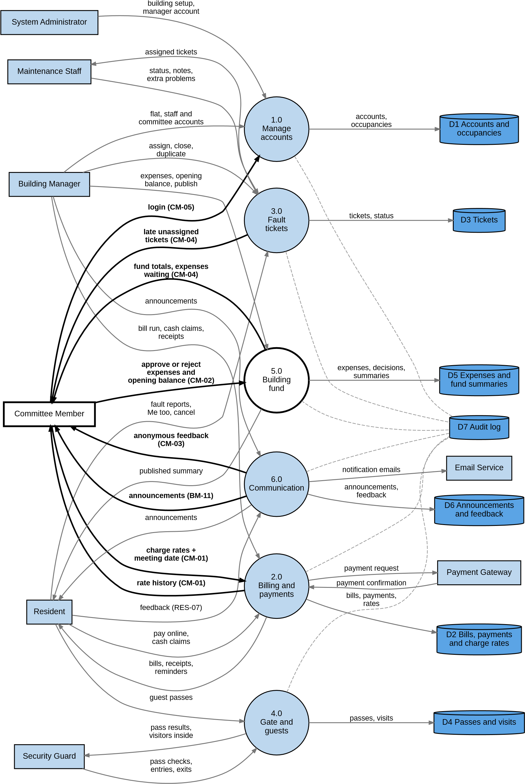
Figure 7.2: Level 0 data flow diagram, six processes
SRS - Committee Member | Page 19

Committee flows in Level 0
Committee flow | Between | Story and data
Login | Committee member → 1.0 Manage accounts | CM-05; UserAccount (role committee)
Charge rates and meeting date | Committee member → 2.0 Billing and payments; rate history back | CM-01; ChargeRate, RateChange (store D2)
Expense and opening balance decisions | Committee member → 5.0 Building fund; fund figures back | CM-02, CM-04; ExpenseDecision,  OpeningBalance, FundSummary (store D5)
Late tickets count | 3.0 Fault tickets → Committee  member | CM-04; Ticket (store D3), counted only
Anonymous feedback | 6.0 Communication → Committee member | CM-03; Feedback (store D6), no flat shown
Announcements | 6.0 Communication → Committee member | BM-11 (committee reads them, SRS 2.1.7); Announcement (store D6). No committee story of its own yet
Every process that changes a record writes the change to the audit log, D7 (dashed lines; NFR-27).
SRS - Committee Member | Page 20

